Experiment 1: Introduction to Matlab
Objective: To be familiar with the basics of Matlab software

Background information
The name MATLAB stands for matrix laboratory. It is an interactive system whose basic data element is a matrix that does not require dimensioning. This allows you to solve many numerical problems in a fraction of the time it would take to write a program in a language such as Fortran, Basic, or C.

MATLAB uses a technical computing environment for high-performance numeric computation and visualization. It integrates numerical analysis, matrix computation, signal processing, and graphics in an easy-to-use environment. It can be operated in two ways: the interpreter mode and the compiler mode. In the interpreter mode, a single calculation or command can be executed. In the compiler mode, MATLAB commands are gathered in an M-file, which is a MATLAB program. The program can be executed like a program of other languages, such as FORTRAN, C.

The version used in the notes is Matlab R2019b. Your matlab version could be the latest version Matlab R2020b. There should not be so much of the difference.

Record the experimental results on your papers. Please note that Matlab is case-sensitive.

Procedure 1: Interpreter Mode
  - Start up
Open MATLAB by double clicking the proper desktop icon (it will be indicated on the blackboard), MATLAB will take a couple of seconds to initialize. Look at the bottom left corner of the MATLAB window (the status bar) and wait unit the wording changes from ‘Initializing …..’ to ‘Ready’.

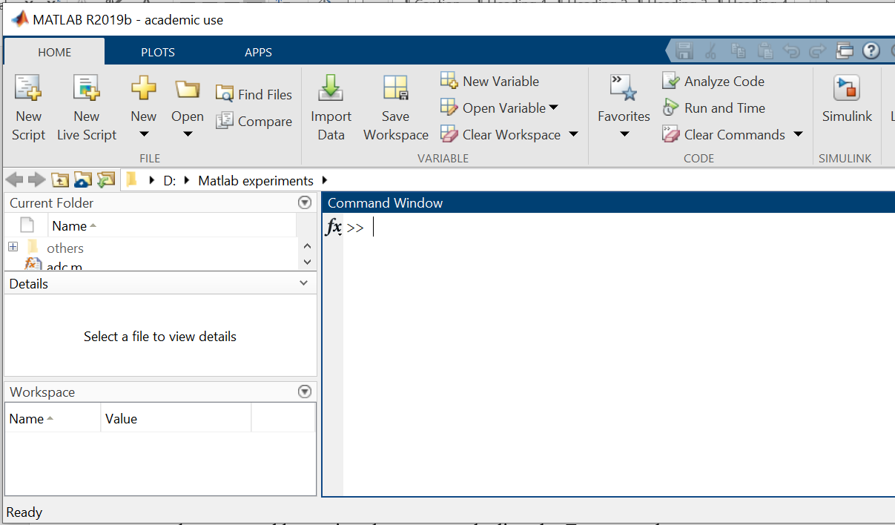

  - Single command
In the MATLAB command window, simple calculations (or operations) can be executed by typing the commands directly. For example, you can type:

>>10+20-40*30/50

What did you observe in the MATLAB window?

You can see that MATLAB can be used as a calculator! However, as we explore more, it will be clear that it can do much more interesting things.

  - Create variables

To list out all the variables in the workspace, type:
>>whos

To clear all the variables in the workspace, type:
>>clear

Now, type:
>>A=6

What response did you get?

Now, again type:
>>whos

What response did you get now?

____________________________________________________________

In MATLAB, all variables are matrices (simple variables and vectors can be thought of as special cases of matrices).

Type:
>>B=[1 2 3; 4 5 6]

The MATLAB window will show the Matrix B.
Type:
>>C=[1 2 3; 4 5 6];

At this point, can you list out all the variables that you have in your workspace? Which MATLAB command should you use?

____________________________________________________________

To see the contents of the variables, just type their names:
>>A
>>B
>>C

Record down what you observed.

____________________________________________________________

If you type:
>>A;

What do you think will happen? Why?

____________________________________________________________

Type:
>>C=[3 4 5 6 7 8 9]

Type:
>>D=[3:1:9]

Is D identical to C?

Type:
>>E=[9:-1:3]

What is the difference between D and E?

Type:
>>F=[9:-2:3]

What is the difference between E and F?

____________________________________________________________

You can also extract an element or a sub-matrix from a matrix. Type the following:
>>D(3)

>>D(2:4)

>>B(2,2)

>>B(1,2:3)

>>B(1,:)

>>B(2,:)

>>B(:,1)

>>B(:,3)
Can you explain how each of the above values is obtained? What is the purpose of this ‘:’?
____________________________________________________________

MATLAB is case-sensitive. Try:
>>b(:,3)

What is the response?

  - Basic calculations – Matrix multiplication
Type:
>>G=A*8;

Write down the value of G. Can you explain how this value comes about?

Type:
>>D

>>D’

What is the difference between D and D’?
____________________________________________________________

Type:
>>D*D'

Write down the answer. Can you explain how this value comes about?

Type:
>>temp=[2 4 6; 3 5 7]'

What is the value of this variable, ‘temp’?

____________________________________________________________

Type:
>>B*temp

What is the answer? Verify the above result by hand.
Note that in matrix multiplication, the dimensions of the two matrices should always fit each other, i.e., m×n followed by n×m.

  - Basic calculations – Elemental multiplication and division
In this mode, two matrices with the same dimension (unless one of them is scalar) are multiplied together element by element. For example,
[1 2] .* [3 4] = [3 8].

To illustrate the effect of elemental multiplication,

Type:
>>B*temp

>>B*temp'

>>B.*temp

>>B.*temp'

You would notice that two of the above expressions would result in an error. Why?

____________________________________________________________

For the other two expressions, can you verify your result by hand?

____________________________________________________________

Why do you need to transpose matrix ‘temp’ when doing elemental multiplication?

____________________________________________________________

Type:
>>B./temp'

What is the answer? Verify your result by hand.

____________________________________________________________

Note that addition and subtraction are always element-wise (unlike multiplication and division). Elemental multiplication and division are very useful when we need to compute many sets of these operations at the same time.

  - Build-in MATLAB functions
There are many build-in functions in the MATLAB library For instance, we can compute trigonometric or exponential functions using MATLAB.

Type:
>>sin(pi/3)

>>exp(-0.5)

Compare the results with 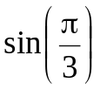 and 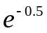 using your calculator.

You can also compute the function for multiple input values.

Try this:
>> clear % clear all the variables on your workspace
>>x=[0 1 2 3];
>>cos(pi/3*x)

What are the results?

____________________________________________________________

Compare your results with 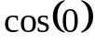, 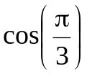, 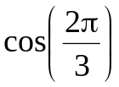 and 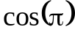 using CALCULATOR.

Most of these functions can also handle complex numbers. Try this:
>>exp(-j*pi/2)

Compare the results with 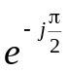.

Sometimes in the MATLAB environment, the variables are used to represent the coefficients of polynomials. Functions that operate on polynomials require such variables. For example, to compute the roots of a polynomial, a variable is first created to represent the coefficients of the polynomial. The following commands solve the equation, 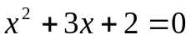.

Type:
>>A=[1 3 2];
>>roots(A)

What does the variable A represent?

What are the roots of the above equation? Verify your result.

A short description is usually given for each build-in function. To access that description, we can use the command ‘help’:

>>help roots

What happens?

Some other build-in function can help you extract or insert numbers in a vector.

Type:
>>J=[ones(1,4),[2:2:11],zeros(1,3)]

>>length(J)

>>J(2:2:length(J))

Explain the results you obtained after each command.

Many tools for plotting and graph are also available.

Type and watch:

>>clear;
>>clc: % clear screen
>>x=[0:0.1:2*pi];
>>y=sin(x)+0.8*cos(2*x);
>>plot(x,y)

Procedure 2: Compiler Mode
- Simple M-file
Instead of executing the MATLAB commands one at a time, you can put a string of them in a file to form a program. This is called an ‘.m’ file (or M-file) which is a collection of sequential MATLAB commands and can be executed in the MATLAB window. To create an ‘.m’ file, go to ‘Home’ menu and, select ‘New Script’. An editor window is opened. In the editor window type in the following commands:

clear;
clc;
t=[1:1:100];
s=sin(4*pi*t/100);
plot(t,s);

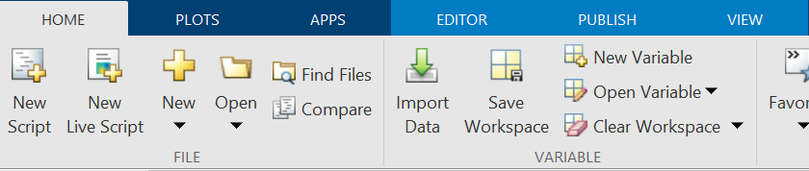

Go to ‘File’ menu, select ‘Save as’ and type in the name of the file as ‘testmat’ (or any other filename that you wish and save to the folder that you choose). In this example, a new folder, Matlab experiments has been created. This file will be saved as ‘testmat.m’. At the MATLAB command window, type:

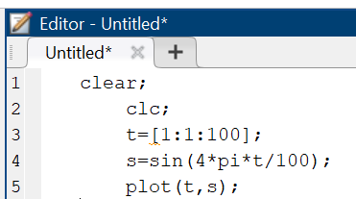

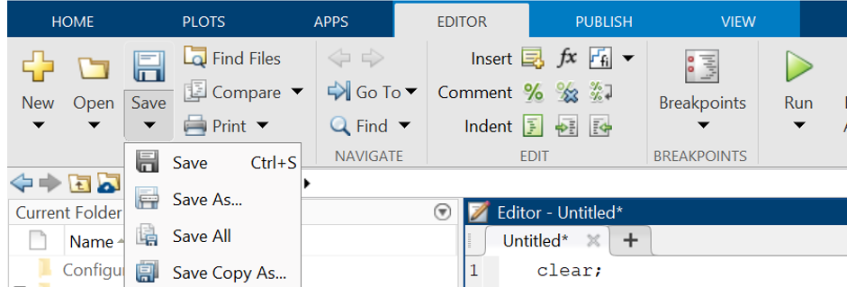

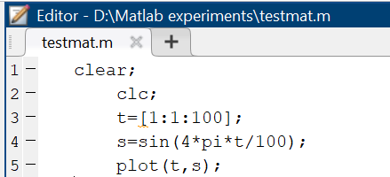

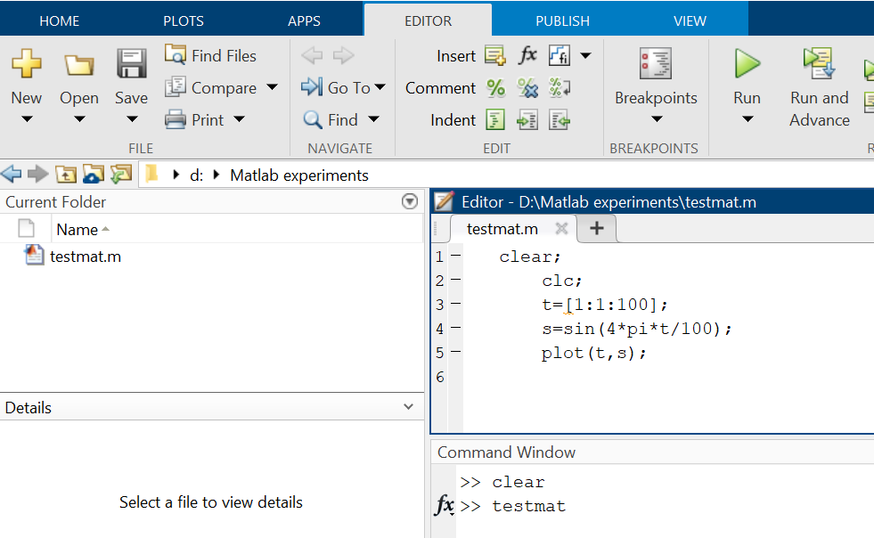

>>testmat

What happened? Can you explain what the program does?

2-2. Loops
In MATLAB programs (M-file), you can also perform loops. Try the following program (you may name it testloop.m):

clear;
clc;
for x=1:5,
y=sqrt(x)
end

What happened?

Modify the program to:

for x=-5:5,
y=sqrt(x)
end

What happened?

2-3. More Practice
Study the following program. Create a new m-file for it and name it ‘test2.m’:
clear;
clc;
t=[1:1:100];
s=sin(4*pi*t/100);
subplot(2,1,1),
plot(t,s);
title('Original signal, s');
axis([0 100 -1.5 1.5]);
grid on;

rs=abs(s);
subplot(2,1,2),
plot(t,rs);
title('rectified signal, rs');
axis([0 100 -1.5 1.5]);
grid on;

Execute the program. What waveform is signal ‘rs?’ What is the function of command ‘subplot,’ ‘axis,’ ‘grid on?’ (Hint: try to use on line help).

Try a second example as saved it under ds.m:

clear;
clc;
t=[1:1:100];
s=sin(4*pi*t/100);
subplot(2,1,1);
plot(t,s);
title('Original signal, s');
axis([0 100 -1.5 1.5]);
grid on;

doubleds=s.*s;
subplot(2,1,2),
plot(t,doubleds);
title('Frequency doubled, doubleds');
axis([0 100 -1.5 1.5]);
grid on;

What waveform is signal ‘ds?’ Is it a sine wave? What is the relationship between waveforms, ds and s?

Try another example: write an m-file as follows:

clear;
clc;
t=-2:0.05:3;
x=sin(2*pi*0.789*t);
plot(t,x), grid on
title(‘Test plot of Sinusoid’)
xlabel(‘Time(sec)’)
ylabel(‘Amplitude(volt)’)

Now amend the program to show the new signal y = 0.75cos(2π0.789t) on top of the previous one (type help plot to see the plot format to see how to show multiple signals at the same frame).

clear;
clc;
t=-2:0.05:3;
x=sin(2*pi*0.789*t);
subplot(2,1,1);
plot(t,x), grid on
title('Test plot of Sine wave')
xlabel('Time(sec)')
ylabel('Amplitude(volt)')
cosinex=0.75*cos(2*pi*0.789*t);
subplot(2,1,2);
plot(t,cosinex), grid on
title('Test plot of Cosine wave')
xlabel('Time(sec)')
ylabel('Amplitude(volt)’)

Exercise - Optional
- Add and plot 2 two sinusoids, at 50 Hz with amplitude 1 and one at 120 Hz with twice the amplitude {i.e., x(t) = x₁(t) + x₂(t)}. Consider generating data with a 1000 Hz sample frequency (you will learn more about this in chapter 3) and the use of time index,

t = (0:0.001:1);

this represents time running from 0 to 1 seconds in steps of 1 ms.

You may want to see only the first 50ms of the signals. Hence, you will have to modify the time index when displaying the signals in the above m file.

>> plot(t(1:50),x1(1:50));
>> plot(t(1:50),x2(1:50));
>> plot(t(1:50),y(1:50));

2. Plot the magnitude of the following expression for 0 ≤ ω ≤ 2π:

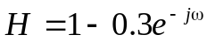

Some MATLAB functions that you may use here are exp, abs and angle. Use the help command to learn more about them.

You can type in the Matlab environment, >> help exp
You can do the same for abs and angle commands

